is a mixture of [metals](https://en.wikipedia.org/wiki/Metal)  and another [element](https://en.wikipedia.org/wiki/Chemical_element). ***Binary Alloys:***

 A binary alloy can have four different types of constitution:

(a) A mixture of two immiscible phases.

(b) A single phase in which atoms of both sorts occupy positions on the same lattice - a solid solution .

(c) A phase with structure different from that of either of the constituents - an intermetallic compound .

(d) An intimate mixture of two phases - a two-phase alloy .

***Definitions***

**Component:** pure metal or compound (e.g., Cu, Zn in Cu-Zn alloy, sugar, water, in a syrup.)

**Solvent:** host or major component in solution.

**Solute:** dissolved, minor component in solution.

**System:** set of possible alloys from same component (e.g., iron-carbon system.)

**Solubility Limit:** Maximum solute concentration that can be dissolved at a given temperature.

**Phase:** part with homogeneous physical and chemical characteristics.

|  |
| --- |
|  |
|  |

***Cooling Curves***

When a solid substance is heated until it is completely melted, and then heated further and allowed to cool slowly, the curve obtained by plotting temperature against time is known as the cooling curve.

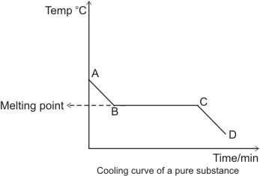

***Cooling curve of pure substance***

Explanations for the cooling curve above:

Between A and B, the temperature falls with time - there is no change of state, hence the substance is still in the liquid state.  
Between B and C, there is a constant temperature over time. This suggests that there is a change of state going on from liquid to solid. The heat lost between these points is that gained in liquefying the solid substance (latent heat of fusion). Hence, there is a balance of heat, which explains why there is no reading of temperature change- this steady temperature is the melting point of the substance and the section, B and C represents liquid/solid state.    
Between C and D, the temperature falls again with time. Here, the substance is totally in the solid state.    
If the substance were a mixture (i.e. consisting of two or more components), we would have more than one level of steady temperature. This is because we would have different melting points for the different components present. Example:

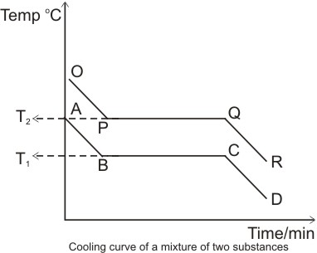

***Cooling curve of a mixture of two substance***

T1 and T2 are the melting points of the two components of the mixture respectively.  
Note: the melting point or freezing point is the temperature at which the solid and liquid phases of a substance can exist in equilibrium. At this point, the solid and liquid phases have the same vapor pressure.

**Differences between Crystalline and Amorphous Solids**

(i)  **Characteristic Geometry:** In *crystalline* solids the particles (atoms, ions, or molecules) are definitely and orderly arranged thus these have characteristic geometry while amorphous solids do not have characteristic geometry.

(ii) **Melting Point:** A crystalline solid has a sharp melting point, i.e., it changes into liquid state at a definite temperature. On the contrary an amorphous solid does not have a sharp melting point. For example, when glass is heated, it softens and then starts flowing without undergoing any abrupt or sharp change from solid to liquid state. Therefore, amorphous solids are regarded as “liquids at all temperatures”.

(iii)  **Cooling curve:** Amorphous solids show smooth cooling curve while crystalline solids show two breaks in cooling curve. In the case of crystalline solids two break points ‘a’ and ‘b’ appear. These points indicate the

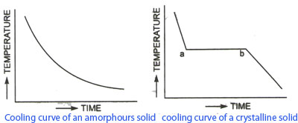

***Cooling curve of crystalline solid***

***Cooling curve of amorphous solid***

beginning and the end of the process of crystallization. In this time interval temperature remains constant. This is due to the fact that during crystallization process energy is liberated which compensates for the loss of heat, thus the temperature remains constant.

***PHASE EQUILIBRIA***

The equilibrium phase is always the one with the lowest free energy(Equilibrium → state with mini um free energy under some specified combination of temperature, pressure, and composition).

***PHASE RULE***

GIBBS PHASE RULE( The Phase Rule) describes the possible number of degrees of freedom in a (closed) system at equilibrium, in terms of the number of separate phases and the number of chemical constituents in the system. **The rule is:**

**F = C - P + 2.**

**Degrees of Freedom** [**F**] is the number of independent intensive variables (i.e. those that are independent of the quantity of material present) that need to be specified in value to fully determine the state of the system. Typical such variables might be temperature, pressure, or concentration.

**Phase**[ **P**] is a component part of the system that is immiscible with the other parts (e.g. solid, liquid, or gas); a phase may of course contain several chemical constituents, which may or may not be shared with other phases. The number of phases is represented in the relation by .

**Chemical Constituents**[ **C]** are simply the distinct compounds (or elements) involved in the equations of the system. (If some of the system constituents remain in equilibrium with each other whatever the state of the system, they should be counted as a single constituent) .

2 for T (*temperature*) and p (*pressure*).\*\*

***Phase Rule – Examples***

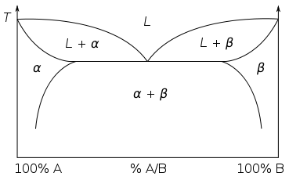

3

1

2

Point: 1

**C = 2 (A and B) P = 1 (liquid)** **F = C - P + 2. F= 2-1+2**

Point: 2

**C = 2 (A and B) P = 2 (liquid and α)**  **F = C - P + 2. F= 2-2+2**

Point: 3

**C = 2 (A and B) P = 3 (liquid and α and β) F = C - P + 2. F= 2-3+2**

***Phase Diagrams***

Phase diagrams provide valuable information about melting, casting, crystallization, and other phenomenon. Phase equilibrium diagrams are plots of the relationship between temperature, pressure and composition.

***Types of equilibrium diagrams***

***Isomorphous systems* -1**

contain metals which are completely soluble in each other and have a single type of crystal structure.

Liquidus line

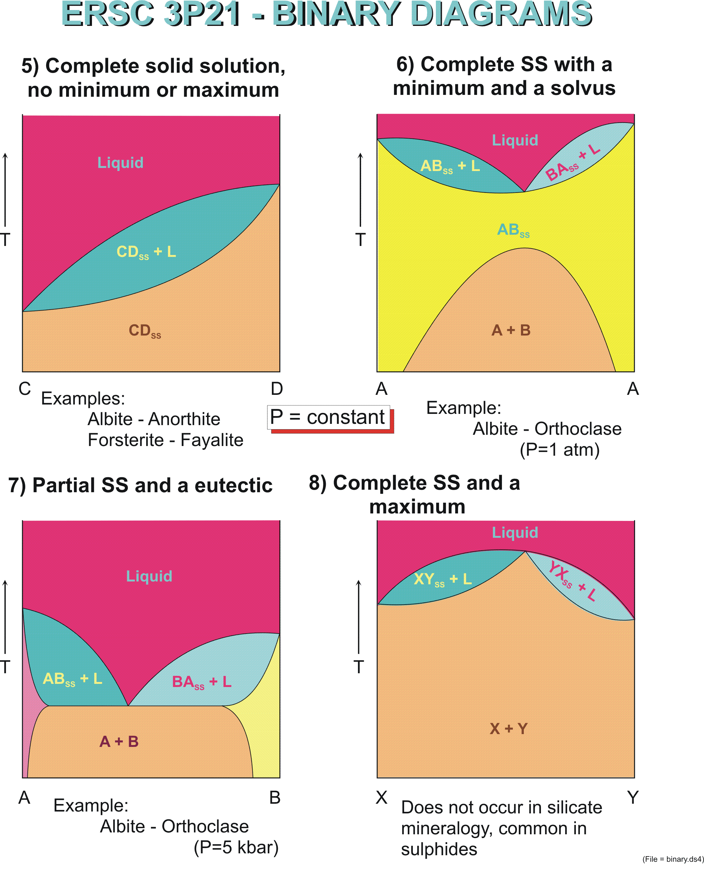

Solidus line

TD

TC

%

\*\* (SS)Solid solution**,** [mixture](http://www.britannica.com/science/mixture) of two [crystalline](http://www.britannica.com/science/crystal) solids that coexist as a new crystalline [solid](http://www.britannica.com/science/solid-state-of-matter), or crystal lattice. The mixing can be accomplished by combining the two solids when they have been melted into liquids at high temperatures and then cooling the result to form the new phase. \*\*(TC)Temperature of Complete Solid Solubility of component C.\*\*(TD)Temperature of Complete Solid Solubility of component D.

\*\*(Liquidus Line) First solid appears on cooling.

\*\*(Solidus Line) Last liquid disappears on cooling.

***Phase Amounts* (Inverse Lever law*)***

The **lever rule** is a tool used to determine weight percentages of each phase of a [binary](https://en.wikipedia.org/wiki/Binary_phase_diagram) equilibrium [phase diagram](https://en.wikipedia.org/wiki/Phase_diagram). It is used to determine the percent weight of liquid and solid phases for a given binary composition and temperature that is between the [liquidus](https://en.wikipedia.org/wiki/Liquidus" \o "Liquidus) and [solidus](https://en.wikipedia.org/wiki/Solidus_(chemistry)).

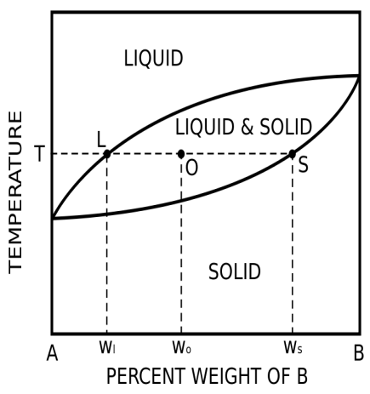

How much liquid and how much

solidAt T and O?

Use Inverse Lever Law

\text{Percent weight of the liquid phase} = X_l = \frac{w_s - w_o}{w_s - w_l}\text{Percent weight of the solid phase} = X_s = \frac{w_o - w_l}{w_s - w_l}

**Example**: 50-50 w% Cu-Ni Cooling from 1400°C,1- What T does 1st solid form?2- What is the comp. of the solid phase? 3-At what T does the last liquid solidify?4- What is the composition of the liquid phase?





-1st solid at 1320°C1

Composition of solid62w% Ni, 38w% Cu - 2

Last liquid at 1275°C- 3

- Composition of liquid37% Ni, 63% Cu 4

***-Binary Eutectic system:*** Limited Solid Solubility***2***



TE

E

Tm(B)

Tm(A)

Melting Temp. (Pure A) :Tm(A)\*\*

Melting Temp. (Pure B) :Tm(B)\*\*

α is solid A with small amount of solid B dissolved in it\*\*

β is solid B with small amount of solid A dissolved in it\*\*

\*\*EEutectic point - the point on a phase diagram where the maximum number of allowable phases are in equilibrium. When this point is reached, the temperature must remain constant until one of the phases disappears.   
TE Eutectic Temp.[ Tm(eutectic) < Tm(A) or Tm(B)]. \*\*

The eutectic reaction is defined as follows:

\text{Liquid} \xrightarrow[\text{cooling}]{\text{eutectic temperature}} \alpha \,\, \text{solid solution} + \beta \,\, \text{solid solution}

***Example***

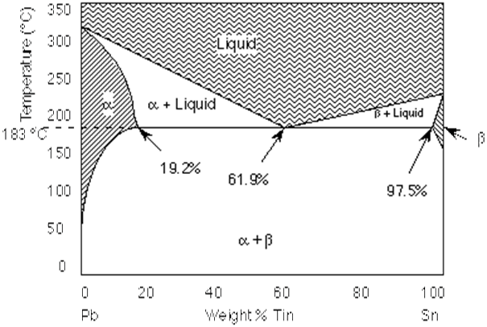

a) What is the eutectic temperature? What is the eutectic composition?

b) A Pb-Sn alloy contains 45% Sn. at 100° C

Answer: a) eutectic temperature: 183° C, eutectic composition: 61.9% Sn

b) wt% α http://www.mrl.ucsb.edu/~edkramer/LectureVGsMat100B/99Lecture13VGs/Image31.gif  wt% β: = 42.4%

***Iron-Carbon (Fe-C) Phase Diagram***

A study of the microstructure of all **steels** usually starts with the [metastable iron-carbon (Fe-C) binary phase diagram](http://www.calphad.com/pdf/Fe_C_Phase_Diagram.pdf) (Figure 1). It provides an invaluable foundation on which to build knowledge of both **carbon steels** and **alloy steels**, as well as a number of various heat treatments they are usually subjected to.

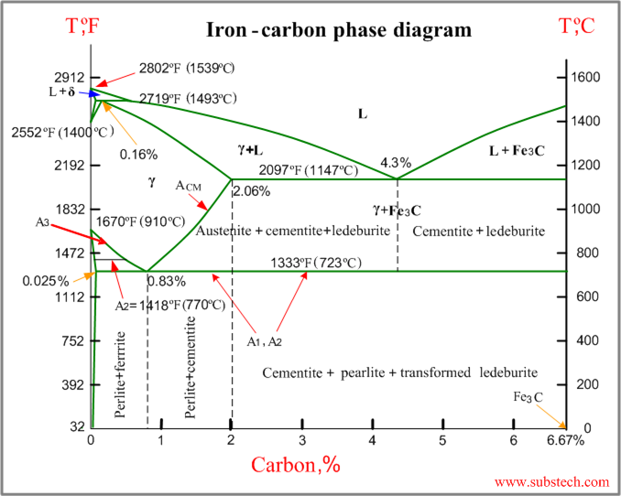

**Following phases exist on Fe-Fe3C diagram: \*\***

- liquid solution of iron and carbon (L)

- ferrite (α) – an interstitial solid solution of carbon in Feα (bcc). At room temperature ferrite is ductile but not very strong.

Ferrite (δ)- solid solution of C in BCC Fe same structure as α-ferrite

stable only at high T, above 1394 C°.

- austenite(γ) - an interstitial solid solution of carbon in Feγ (fcc).

- cementite (Fe3C)- hard and brittle compound with chemical formula Fe3C. It has metallic properties.

-Perlite (P)- is a structure (i.e. consists of two phases) consists of alternate layers of ferrite and cementite in the proportion 87:13 by weight. Perlite is formed from austenite at eutectoid temperature (A1) 723°C upon slow cooling.

**Following temperature exist on Fe-Fe3C diagram:** \*\*

|  |  |
| --- | --- |
| 723°C | **A1** |
| 770°C | **A2** |
| 910°C | **A3** |
| 1493°C | **A4** |
| °C 1539 | **ATm** |
| 1174°C | **Acm** |

**There are three groups of steels according to carbon content:** \*\*

- hypoeutectoid steels containing less than 0.76% C

- eutectoid steel with carbon content about 0.76%

- hypereutectoid steels contain more than 0.76% C (up to 2% C).

\*\* **On a base of Fe-Fe3C diagram we can divide iron-carbon alloys into:**

**steels,** is an alloy of carbon and iron and other alloying elements (e.g. Mn, Si) with carbon content up to 2% intended for wrought products or semi products.

**Cast iron** is an alloy of carbon and iron and other alloying elements (e.g. Mn, Si) with carbon content over 2% intended for castings.

***Eutectic and eutectoid reactions in Fe–Fe3C***

**Eutectic:** 4.30 wt% C, at 1147° C [ L ↔γ + Fe3C]

**Eutectoid:** 0.76 wt%C, at 727° C [ γ(0.76 wt% C) ↔α (0.022 wt% C) + Fe3C]



**Eutectoid:** 0.76 wt%C, at 727° C

[ γ(0.76 wt% C) ↔α (0.022 wt% C) + Fe3C]

**Eutectic:** 4.30 wt% C, at 1147° C [ L ↔γ + Fe3C]

***Problem***

0.45%C plain-carbon steel is slowly cooled from 1400° C to a temperature just slightly above 750 °C. what phases present before and after cooling, and Calculate their weight percent?

**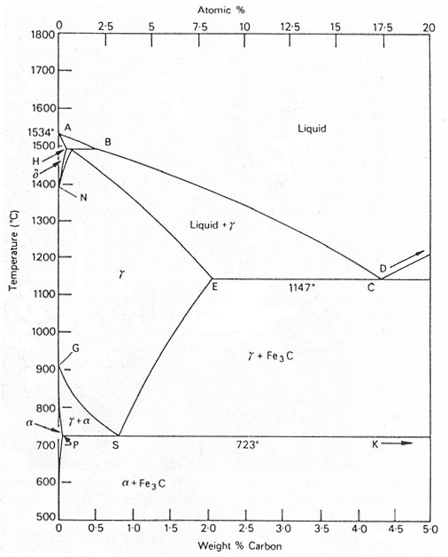**

At 1400°C phase is γ

At 750°C phase is (α+γ)

$$×100=17.8\%$$

. 53 – 0. 45 0

wt% α =

0.53-0.08

. 45 – 0. 08 0

wt% γ =

$$×100=82.2\%$$

0.53-0.08